**Project Progress:**\*\*\* for *** testing from *** to **.   
Rest of Time: ** workdays

**For QA:**The latest status of bugs(Whole Rooms Clients/Web Backend/Linux)

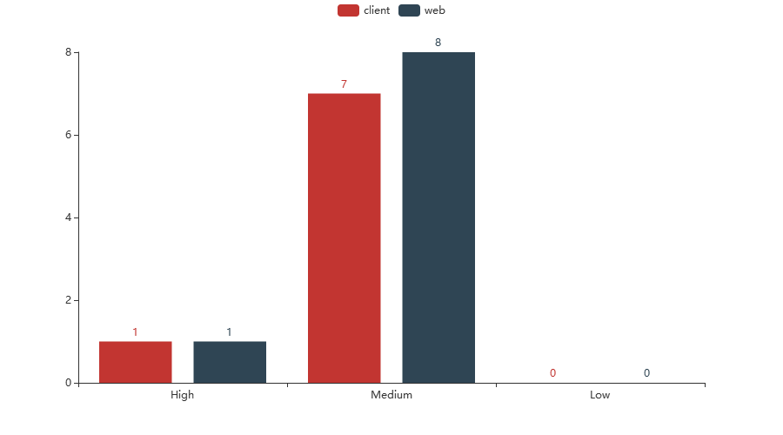

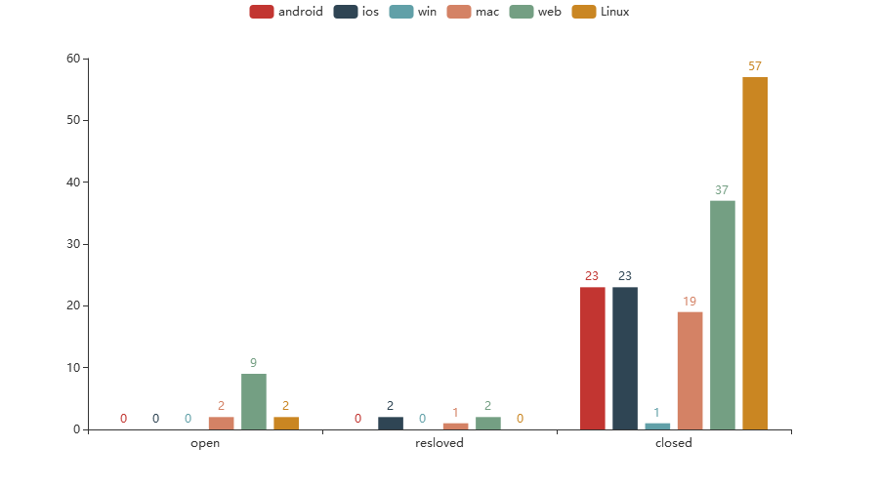

The latest status of TestCases Executed:

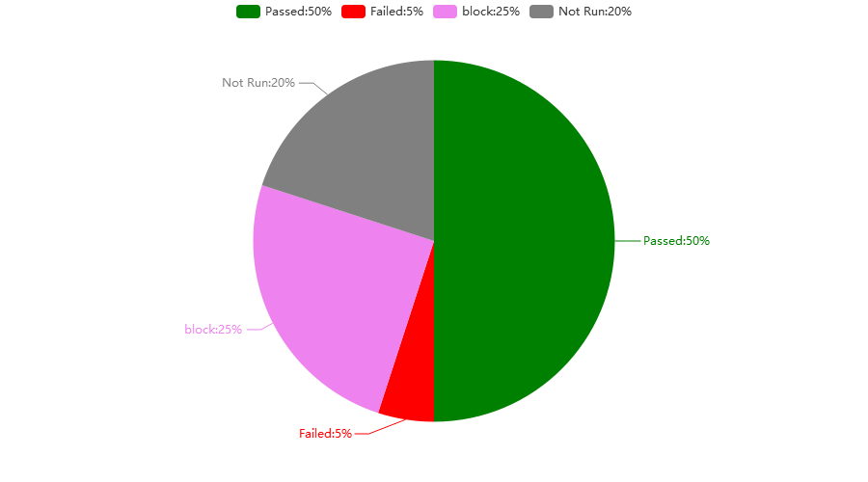

Latest testing builds root folder: ***

**For PM:   
The latest status of Epic/User story**

